Lakshmi Vyshnavi perla

Bhargavi Sandhya podile

**HOME PAGE**

the below is the home page of the application which contains three options youtube, tic tac toe, twitter

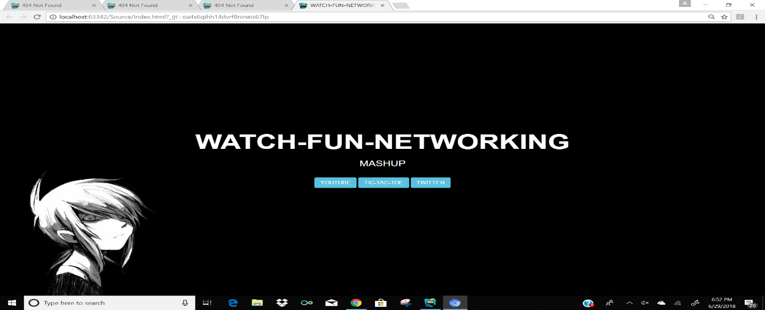

**YOUTUBE**

after clicking the you tube button we will be directed to the you tube page where we can get the required vedios.

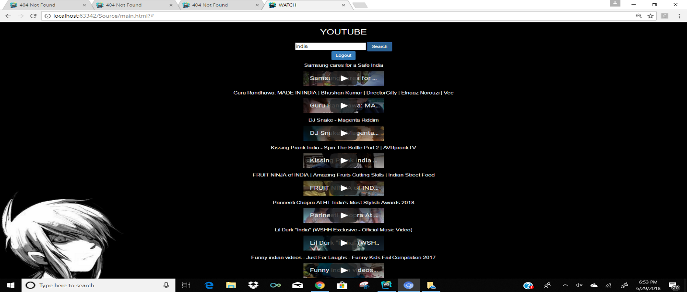

**TIC-TAC-TOE**

This is the game where similar diagonal and straight symbols win. After clicking the tic tac toe button in the home page we will be redirecting to the below page. here two players can play the game with circle and cross symbols.

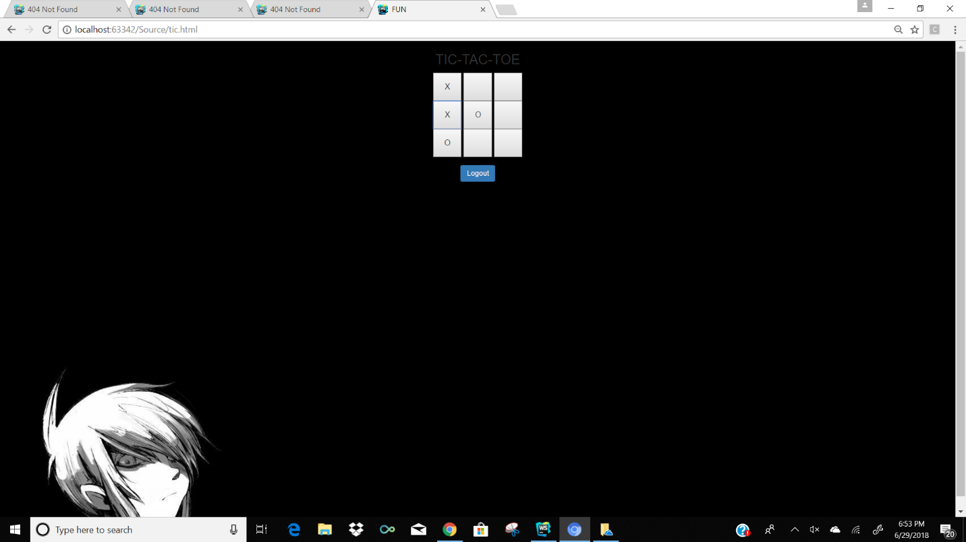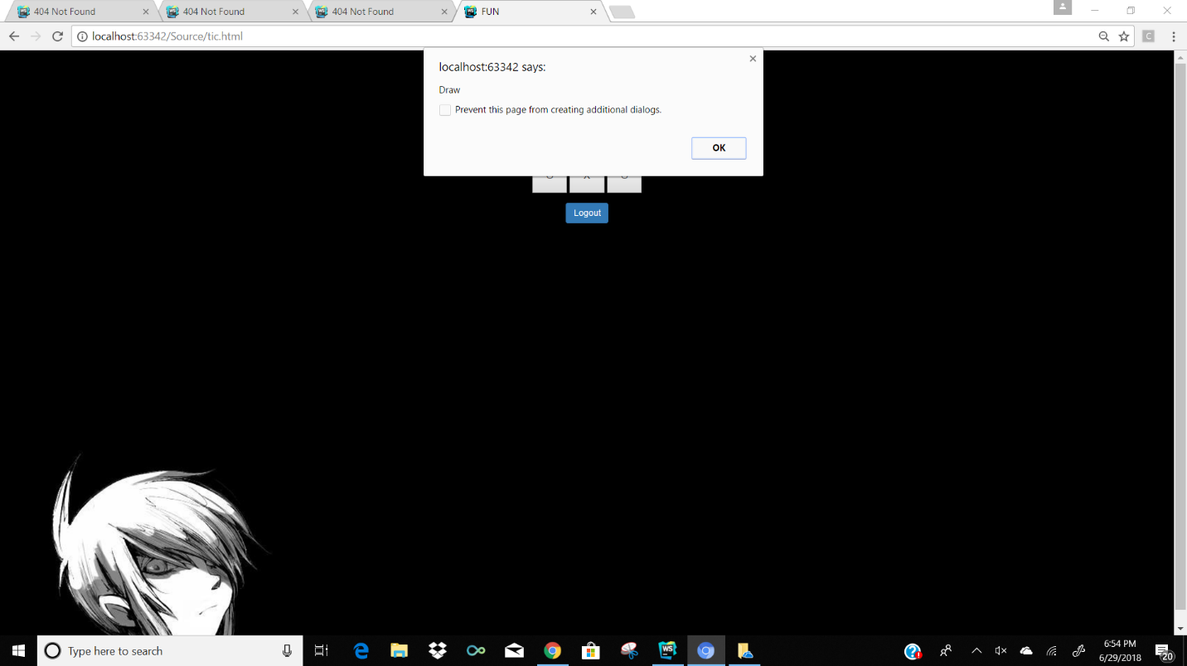

**TWITTER**

Here in the twitter page we will be getting the followers of the given user name.

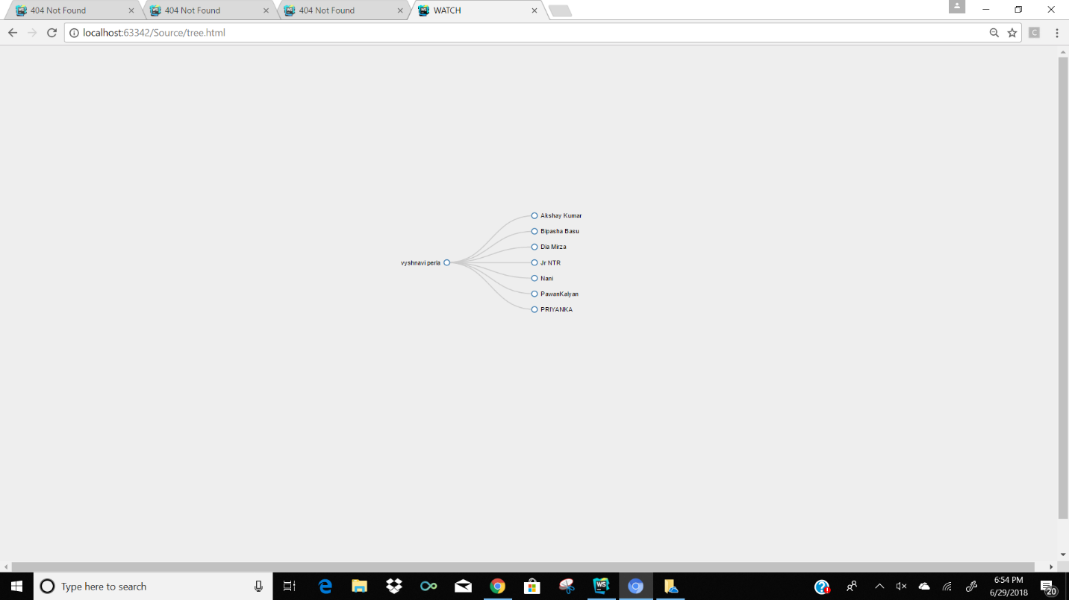

**CODE SNIPPET**

